GNAQ (Q209L)
Catalog Number: CR-M26328
Gene Symbol: GNAQ, CMC1, G-ALPHA-q, GAQ, SWS
Description: Anti-GNAQ (Q209L) Mouse Monoclonal Antibody

Background: GNAQ is a protein that in humans encoded by the GNAQ gene. The GNAQ protein, an alpha subunit in the Gq class, couples a seven-transmembrane domain receptor to activation of phospholipase C-beta. Mutations at this locus have been associated with problems in platelet activation and aggregation.
Immunogen: A synthetic peptide from the internal region of GNAQ which includes the mutation of Q209L, human origin.
Tested applications: ELISA, WB, IHC
Recommended dilutions:
ELISA: 1:1000-1:2000
WB: 1:500-1:1000
IHC: 1:50-1:100
Concentration: 1 mg/ml
Host: Mouse
Clonality: Monoclonal
Purity: Purified from ascites
Format: Liquid
Storage buffer:
Preservative: no
Constituents: PBS (without Mg²⁺ and Ca²⁺), pH 7.4, 150 mM NaCl, 50% glycerol
Species Reactivity: Recognizes Q209L mutant, but not wild-type GNAQ of vertebrates.
Storage Conditions: Store at -20°C. Avoid freeze / thaw cycles.

Western blot:
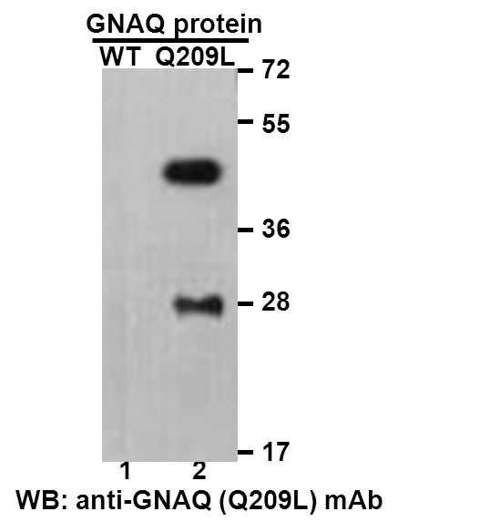
Western blot analysis of recombinant GNAQ (Q209L) and wildtype proteins. Purified His-tagged GNAQ (Q209L) protein (lane2) and corresponding wild-type protein (lane1) were blotted with anti-GNAQ (Q209L) monoclonal antibody (Cat. #26328).

Immunofluorescence:
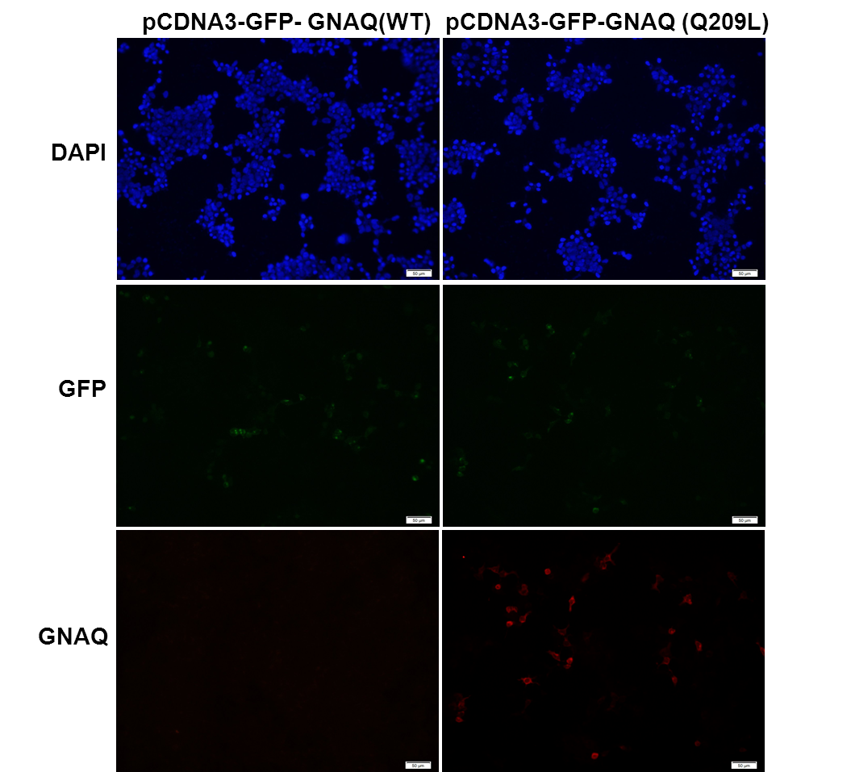
Immunofluorescence of cells expressing GNAQ proteins with anti-GNAQ (Q209L) antibody. HEK293T cells were transfected with pCDNA3-GFP-GNAQ (WT) plasmid (left column) or pCDNA3-GFP-GNAQ (Q209L) plasmid (right column), then fixed and stained with anti-GNAQ (Q209L) monoclonal antibody (Cat. #26328).

